Smart SDLC – AI-Enhanced Software Development

Lifecycle project Documentation

1. Introduction

Project Title - SmartSDLC – AI

Team Member

Naveen Kumar.T

Subash.S

Shanmugaraj.S

Nitheesh Kumar.A

1. Project Overview

Purpose

The traditional Software Development Life Cycle (SDLC) provides a structured approach for building software systems. However, with the growing complexity of applications, distributed teams, and the need for rapid deployment, AI-enhanced SDLC (Smart SDLC) introduces intelligent automation and predictive analytics to make the development process more efficient, adaptive, and reliable.

Smart SDLC integrates AI-driven tools at each stage— requirements, design, coding, testing, deployment, and maintenance—optimizing cost, time, and quality.

3.Objectives of Smart SDLC :

Automate repetitive tasks in development and testing.Use AI for predictive project planning and risk detection.

Enhance code quality through intelligent reviews and error detection.

Provide data-driven insights for continuous improvement. Reduce human errors and accelerate time to-market.

1. AI-Enhanced SDLC Phases:
   1. Requirement Analysis:

Traditional Role: Gather requirements from stakeholders.

AI Enhancement:NLP-based tools extract requirements from documents, emails, and conversations.

AI-driven sentiment analysis to detect hidden needs or conflicts.

Predictive analysis of requirement changes and their impact.

* 1. System Design:

Traditional Role: Define architecture and system specifications.

AI Enhancement:

AI-assisted UML diagram generation and architecture recommendations.

Generative design tools suggest optimal data models and frameworks.

Predict design flaws or scalability issues before implementation.

* 1. Implementation (Coding):

Traditional Role: Developers write and compile code.

AI Enhancement:

AI coding assistants (e.g., Copilot-like tools) generate boilerplate code.

Code optimization using machine learning for performance tuning.

Intelligent error detection during coding, reducing debugging effort.

* 1. Testing:

Traditional Role: Manual and automated test execution.

AI Enhancement:

AI test case generation from requirements and code changes.

Predictive defect analysis to identify high-risk modules.

Self-healing test automation that adapts to UI or API changes.

* 1. Deployment:

Traditional Role: Release software into production.

AI Enhancement:

AI-driven CI/CD pipelines that auto-optimize builds.

Predictive analytics for release readiness.

Smart rollback mechanisms in case of failures.

* 1. Maintenance & Monitoring:

Traditional Role: Fix bugs, update features, monitor performance.

AI Enhancement:

AI-based log analysis to detect anomalies or threats.

Predictive maintenance—forecasting when updates are required.

Intelligent chatbots for end-user s upport.

5.Benefits of Smart SDLC:

Reduced Development Time: AI-generated code & automated testing.

Improved Quality: Predictive defect detection and design flaw prevention.

Cost Efficiency: Fewer manual tasks and reduced rework.

Continuous Adaptation: AI learns from past projects to optimize future workflows.

Better Decision-Making: Data-driven insights at each phase

—

6.Challenges & Considerations:

Data privacy and security while using AI tools.

Bias in AI models may affect predictions.

Dependence on AI may reduce human critical thinking if not balanced.

Integration of AI tools with existing DevOps pipelines.

7.Future Scope:

Fully autonomous SDLC pipelines with minimal human intervention.

AI-based governance models for compliance and ethics.l

Enhanced collaboration between human developers and AI agents (Hybrid Teams).

8.screenshort:

Coding:

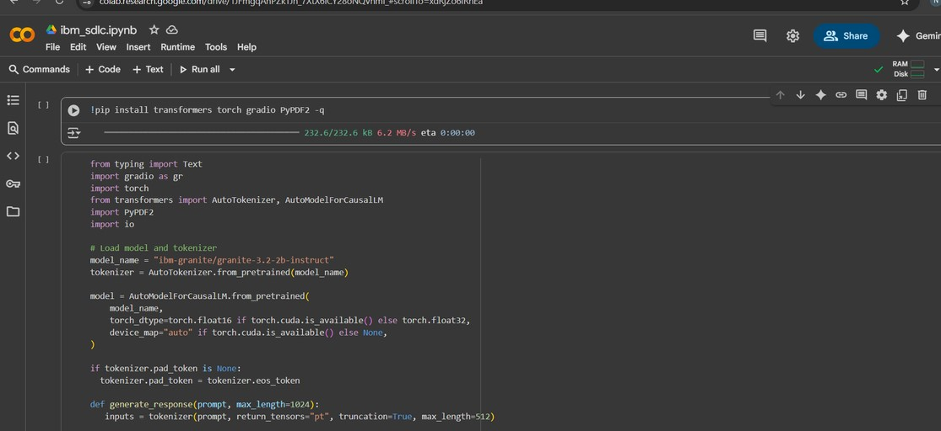

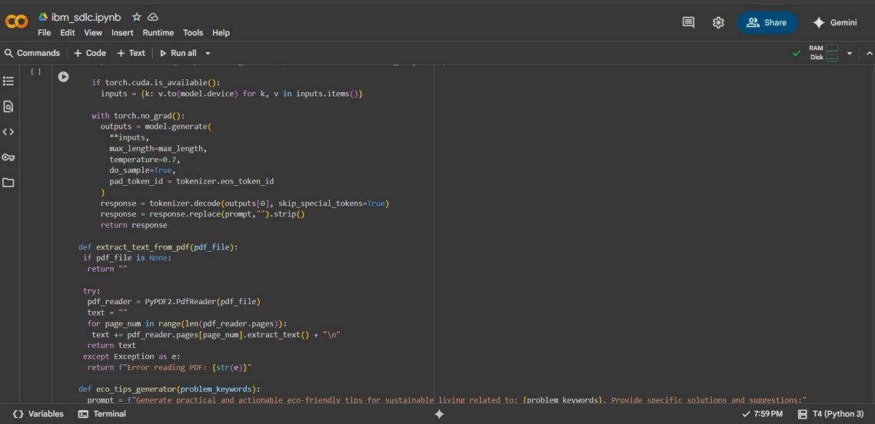

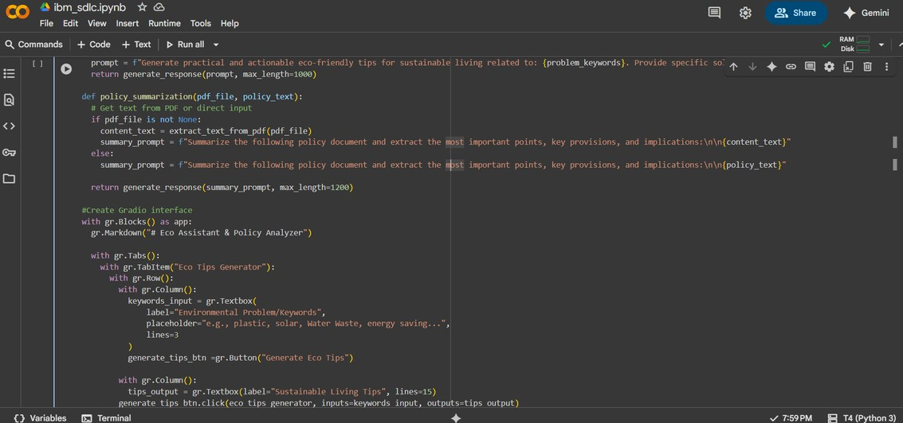

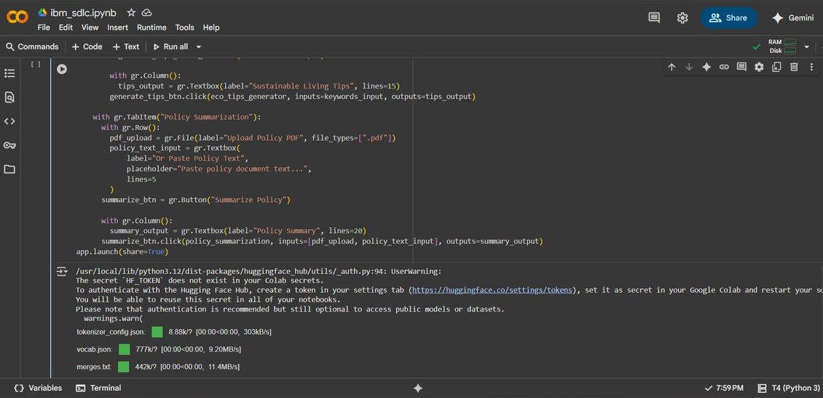

implementation:

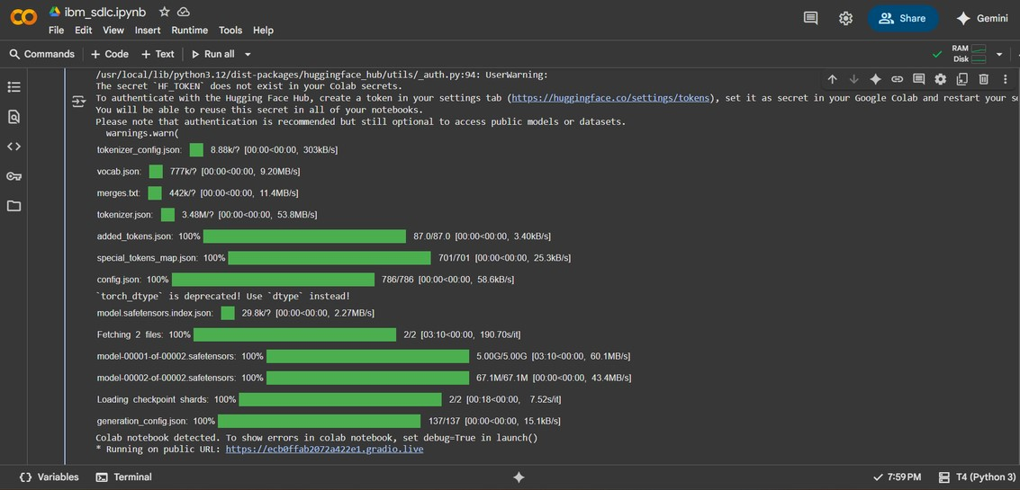

output:

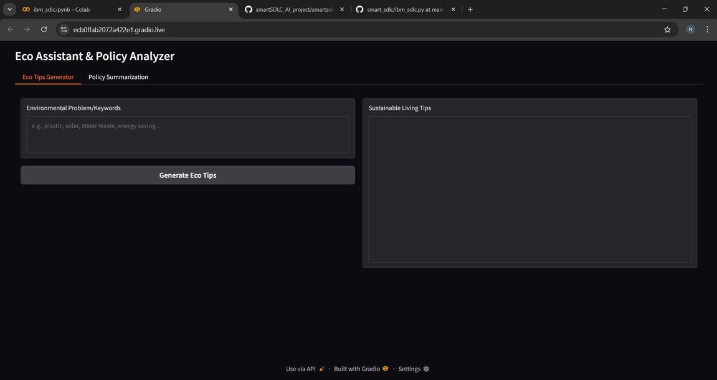

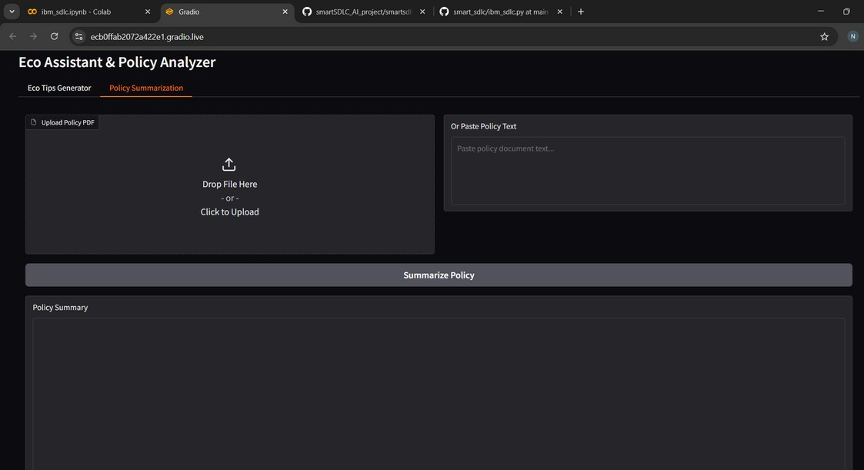

9. Known Issues

1. Requirement Ambiguity

Incomplete, unclear, or changing requirements.

Leads to rework and cost overruns.

1. Communication Gaps

Misunderstanding between stakeholders, developers, and testers.

Causes misalignment in final product.

1. Time & Cost Overruns

Due to poor estimation or unexpected technical challenges.

1. Integration Challenges

Difficulty in integrating new systems with legacy applications.

1. Testing Bottlenecks

Delayed or insufficient testing.

Bugs found late in development cycle.

1. Security Vulnerabilities

Ignoring security early in SDLC leads to data breaches later.

1. Resource Dependency

Over-reliance on key developers or technologies.

1. Scalability Issues

Some applications fail to scale with user demand if not designed properly.

10. Future Enhancements

1. AI-Driven Development

Use of AI tools for automated coding, bug detection, and testing.

Predictive analytics for project risks and delivery timelines.

1. Agile + DevOps Integration

Seamless CI/CD pipelines for faster deployment.

Continuous monitoring and feedback loops.

1. Low-Code/No-Code Platforms

Empower non-developers to build simple applications.

Faster prototyping and reduced dependency on large dev teams.

1. Cloud-Native SDLC

Development and testing directly on cloud environments.

Scalability and cost optimization.

1. Enhanced Security (DevSecOps)

Security integrated at every stage of SDLC.

AI-powered vulnerability scanning and auto-patching.

1. Smart Documentation & TraceabilityAutomated documentation using AI.

Real-time requirement-to-code mapping.

1. Sustainability & Green SDLC

Focus on energy-efficient coding practices.

Cloud optimization for reducing carbon footprint.